**FLASK PROJECT**

**USING COMMAND PROMPT TO SET THE PATH**

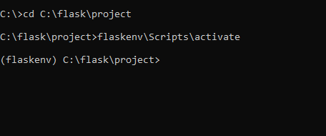

**IMPORTING FLASK,REQUESTS AND PYMYSQL MODULES**

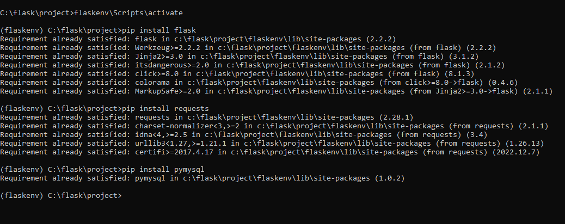

**CREATING A HTML FILE NAMED FIRST.HTML**

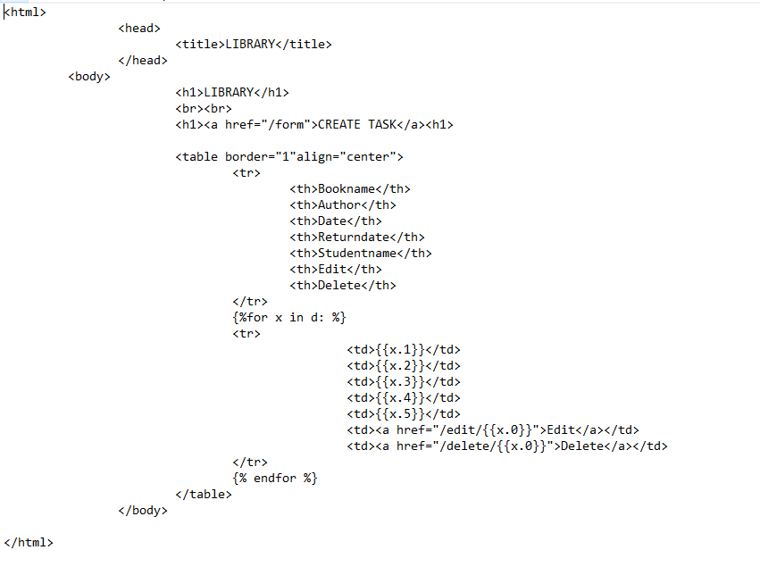

**CREATING ANOTHER HTML FILE NAMED AS SECOND.HTML**

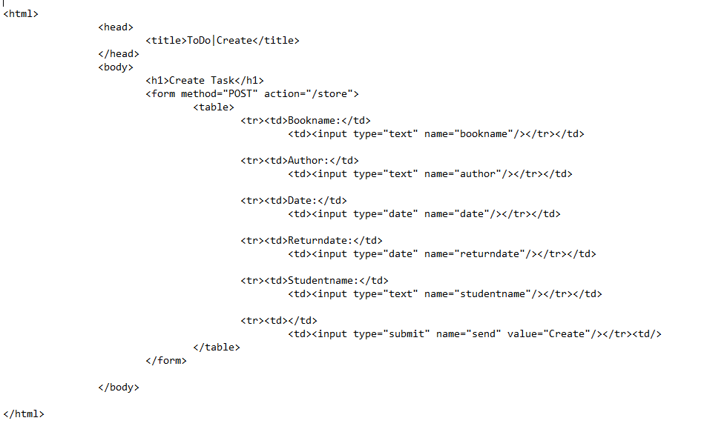

**CREATING ANOTHER HTML FILE NAMED AS THIRD.HTML**

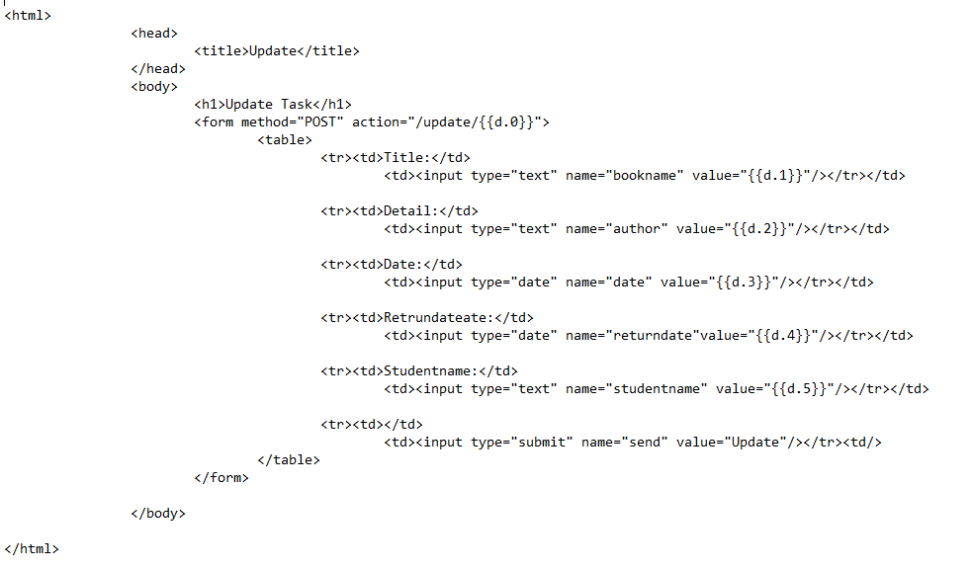

**CREATING A SQL TABLE TO PERFROM THE OPEARTION.**

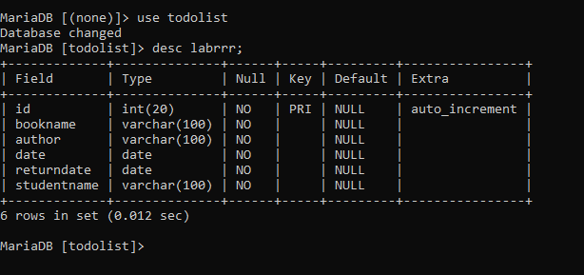

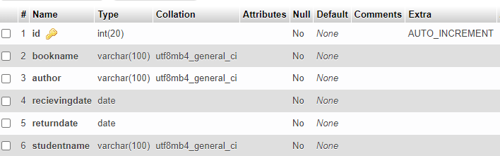

**NOW WE ARE GOING TO CONNECT BACKEND AND FRONTEND USING PYTHON**

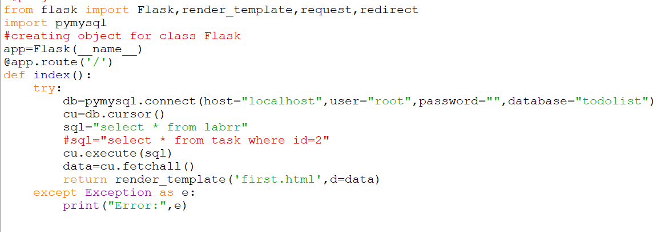

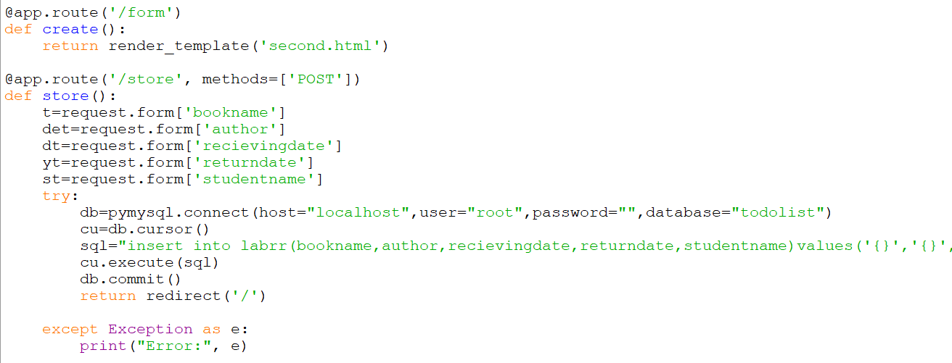

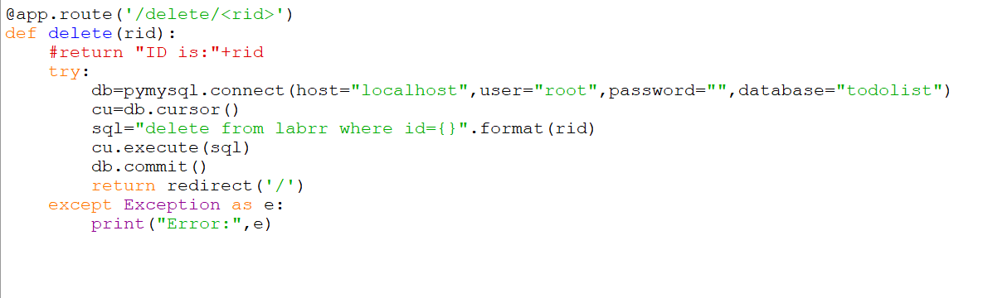

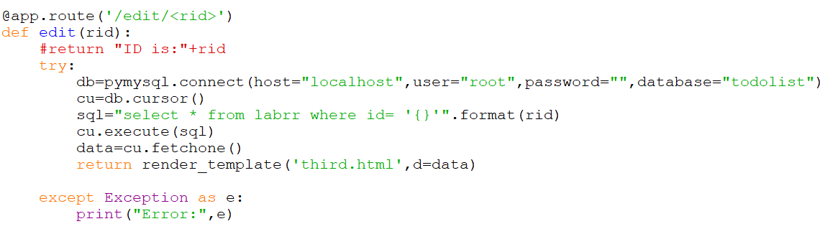

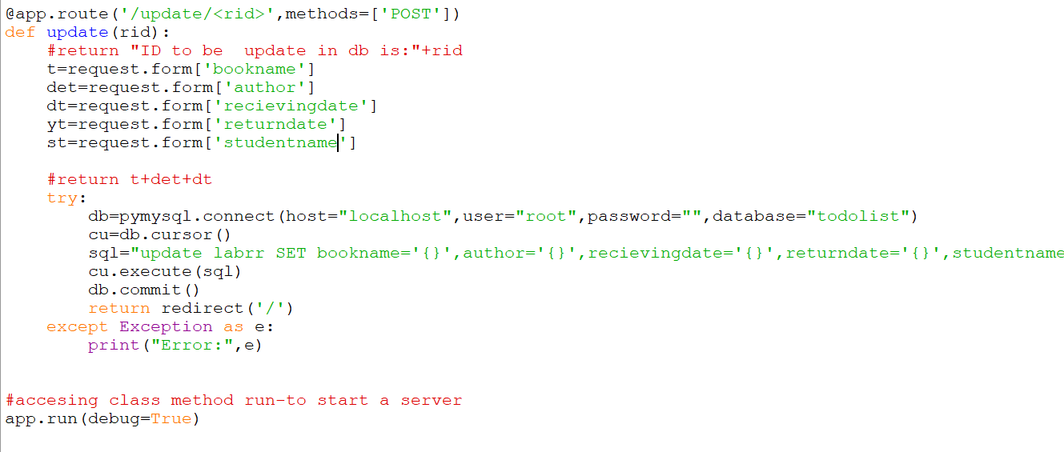

**NOW WE ARE GOING TO RUN THE PROGRAM IN CMD**

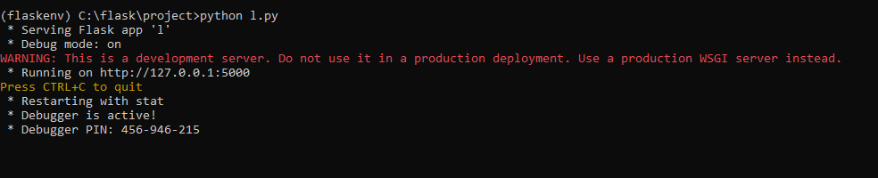

**PASTE THE URL IN YOUR BROWSER**

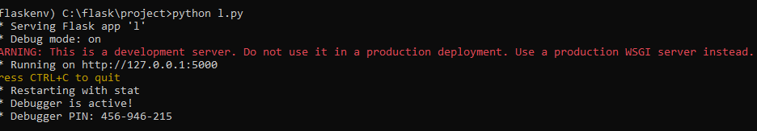

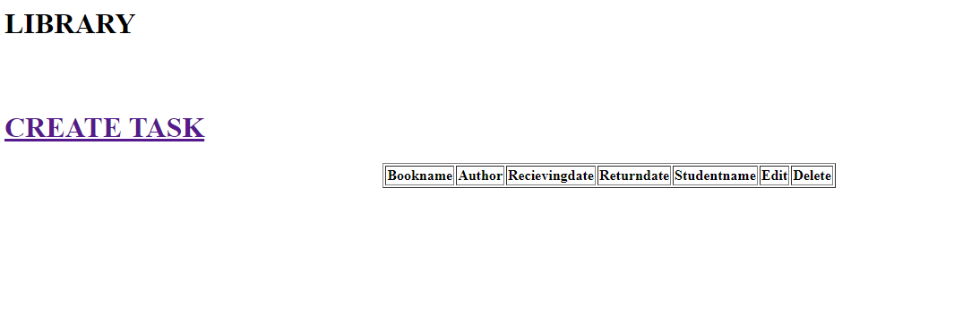

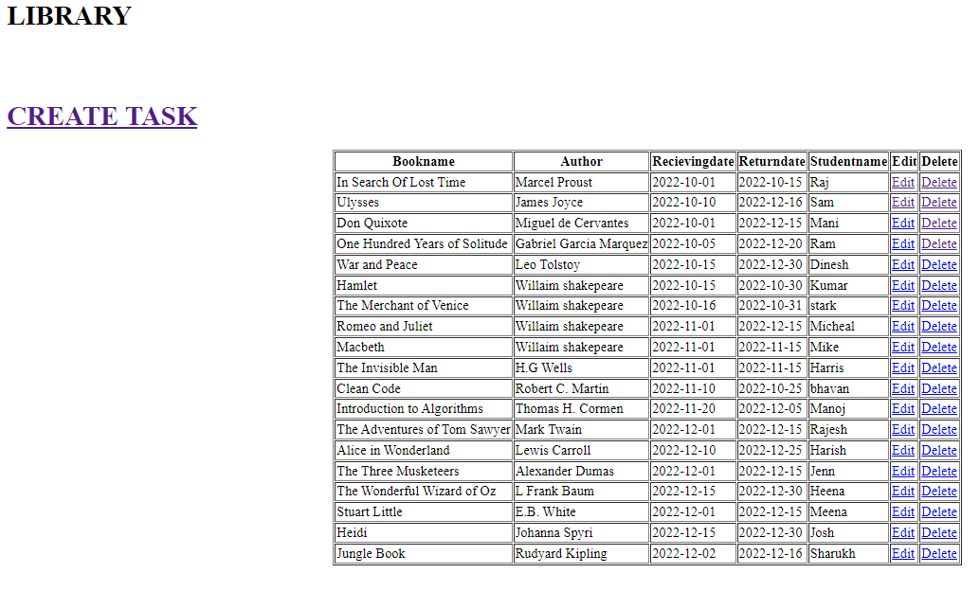

**WE CAN UPDATE,EDIT,DELETE ACCORDING TO OUR NEEDS**

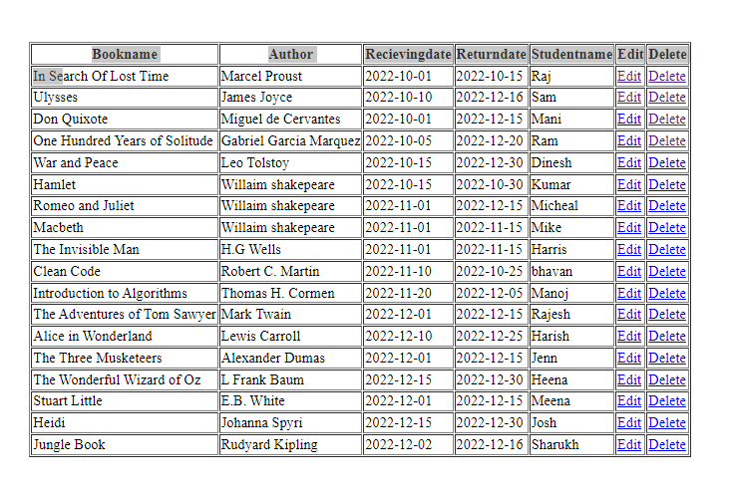

**NOW SEE A ROW IS DELTED**

